- Dr. Ramdew Ram Kairy  Prof. of Ortho. Surgery  NITOR, Dhaka.  Date of Birth- 20-03-1954  Year of M.B.B.S.- 1977  Year of Post graduation: M.S 1983 (NITOR)  Mobile:-  E-mail: dr_kairy@yahoo.com | 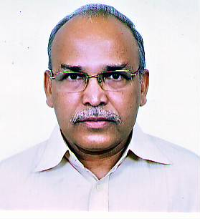
Dr. Md. Abdus Samad  Prof. of Ortho Surgery  NITOR, Dhaka.  Date of Birth- 01-01-1954  Year of M.B.B.S.-1978  Year of Post graduation: D. Ortho. 1984, M.S 1993(NITOR)  Mobile:-  E-mail: | 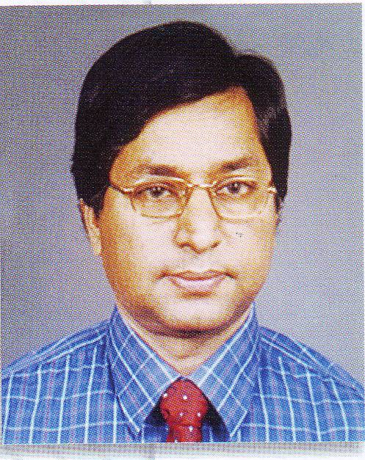
Dr. Sarwar Ibne Salam  Asst. Prof. (Orthopaedic) DMCH  60, Ulon, Ranpura  Dhaka- 1219  Date of Birth- 22/09/1966  Year of M.B.B.S.- 1992  Year of Post graduation: M.S 2006(NITOR)  Mobile:-  E-mail: sarwarsalam@gmail.com | 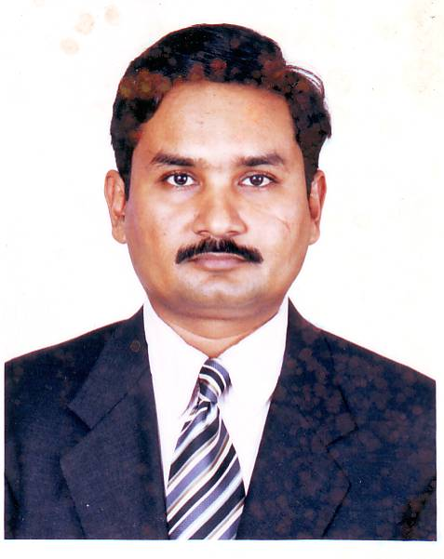

Dr. A.K.M. Zahiruddin  Asst. Prof. of Ortho Surgery  NITOR, Sher-e-Bangla Nagar, Dhaka-1207.  514 West Nakhalpara, Tajgoan, Dhaka.  Date of Birth- 01/07/1962  Year of M.B.B.S.- 1987  Year of Post graduation: M.S 2006 (NITOR)  Mobile:-  E-mail:drzahiru@yahoo.com | 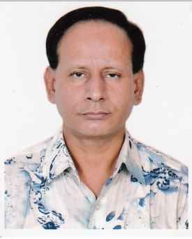
Dr. Md. Mehedi Newaz  Asstt rof. of Ortho Surgery  Khulna Medical College Hospital  Date of Birth- 16/01/1969  Year of M.B.B.S.- 1996  Year of Post graduation: M.S 2006(NITOR)  Mobile No-  E-mail: drmehedinewaz@yahoo.com | 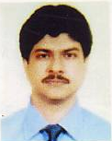
Dr. Dipankar Nath Talukder  Asst.Prof.. of Orthopaedic Surgery  MAG Osmani Medical College Hospital,  Sylhet  Date of Birth- 01-01-1958  Year of M.B.B.S.- 1983  Year of Post graduation: M.S 1996  Mobile:-  E-mail: anapaneyo@hotmail.com | 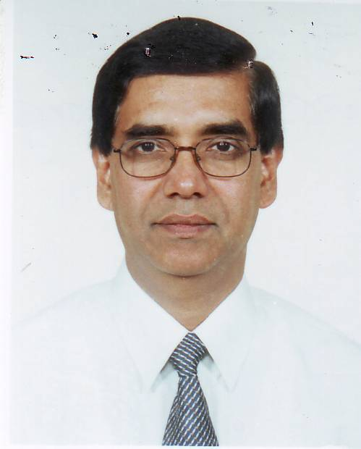
Dr. Sayed Ahmed  Asst. Prof. Of Ortho surgery  Rajshahi Medical College Hospital  Rajshahi  Date of Birth- 30/06/1956  Year of M.B.B.S.- 1982  Year of Post graduation: D. Ortho. 1988 M.S 1998(NITOR)  Mobile:  E-mail: sayed506@hotmail.com | 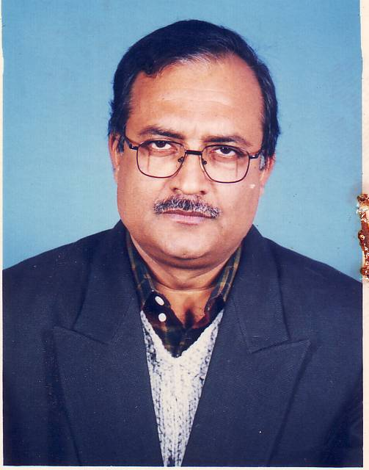
Dr. Moinuddin Ahmed Choudhury  Assoc. Prof of Orthopaedic Surgery  SSMC & Mitford Hospital, Dhaka  Date of Birth- 06/10/1963  Year of M.B.B.S.- 1988  Year of Post graduation: M.S 2002(NITOR)  Mobile:-  E-mail: moinuachy@yahoo.com | 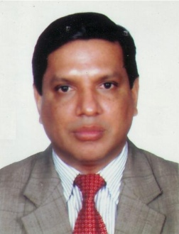
Dr. Md. Somirul Islam  W-D-5, West Ferozsha  Chittagong-4207  Date of Birth- 04/07/1970  Year of M.B.B.S.- 1996  Year of Post graduation: M.S NITOR (2007, Jan)  Mobile No-  E-mail: somirul10@yahoo.com | 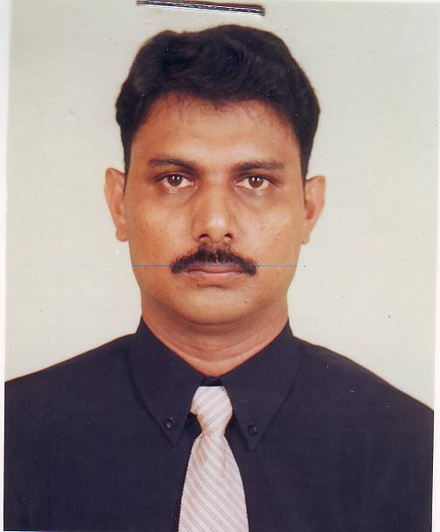
- Dr. Parviz Shahidi Ghamsar  Prof. & Head  Shaheed Monsur Ali Medical College Hospital  Sector- 11, Uttara, Dhaka  Date of Birth- 01-02-1958  Year of M.B.B.S.- 1984  Year of Post graduation: M.S 1998 (NITOR)  Mobile:-  E-mail: parvizshahidi@hotmail.com | 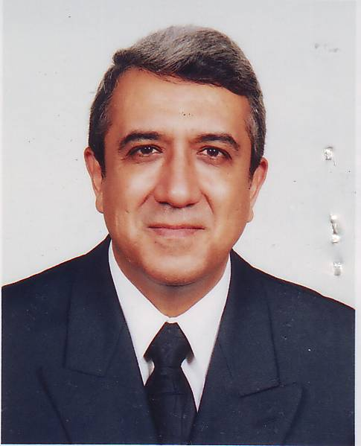
Dr. Shyamal Chandra Debnath  Asstt. Prof of Orthopaedic Surgery  Add Jobeda’s Dream, House No-3/12,  Flat No-3/B, Iqbal Road,  Mohammadpur, Dhaka-1207  Date of Birth- 01-01-1963  Year of M.B.B.S.- 1987  Year of Post graduation: M.S 1998  Mobile:-  E-mail: debnathshyamal@yahoo.com | 