Formation of POSB
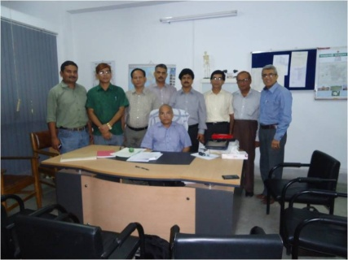 : 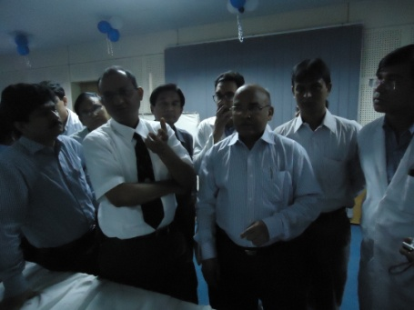
Dear Colleagues
It gives us immense pleasure to inform you that Paediatric Orthopaedic Society of Bangladesh (POSB) has been formed on 6th September 2012 with the goal of developing this Orthopaedic sub specialty in Bangladesh.
The 1st meeting of POSB was chaired by Prof R R Kairy & the following ad hoc committee was formed. The office bearers are as follows:
President : Prof R R Kairy (01711522817)
Vice President: Prof M A Samad (01711545268)
General Secretary: Dr Sarwar Ibne Salam (01819403408)
Treasurer : Dr A K M Zahiruddin (01552305262)
Asst Gen Secretary : Dr Mehedi Newaz (01711680710)
Organizing Secretary: Dr Shyamal Chandra Debnath (01819242363)
International & Scientific Secretary : Prof Parviz Shahidi Ghamsiri (01711561118)
Members : Dr Sayed Ahmed (01713228354)
Dr Dipankar Nath Talukdar (01711859677)
Dr Moinuddin Ahmed Chowdhury(01713020012)
Dr Somirul Islam (01711155895)

There are three types of memberships
- Life member ( Any orthopaedic Surgeon who has a recognized Orthopaedic Post Graduation at least 5 years back) ,
- Associate member ( Any orthopaedic Surgeon who has a recognized Orthopaedic Post Graduation within last 5 years ) ,
- Honorary member. Any eminent person from Bangladesh or abroad who has made significant, contributions to the cause of Paediatric Orthopaedic Surgery.

